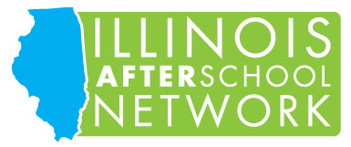

ORGANIZATIONAL LEVEL MEMBERSHIP FORM

Organization Name:

Organization Address:

City: State: Zip: County:

Contact Person: Work Email:

Work Phone: Work Fax:

Organization Type (check all that apply):

Child Development Center Youth-Serving Organization (YMCA/YWCA, Boys & Girls Clubs, etc.)
Church/Religious Organization School Family Child Care CCR&R
Private, not for profit agency Private, for profit Military Other:

Funding Sources (check all that apply):

CCAP 21st Century CLC Teen Reach Fees Other:

# of children and youth served by your agency: ______

Membership history:
New Organizational Member
Renewing Member / Year you joined IAN:

Organizational Level Membership Fee: $60 per member
Organizations must enroll members at the same time and make full payment.
Memberships must be renewed annually. Membership prices are subject to change.

Please provide the name and email address below for each individual to be included in your organization’s membership. Please note a minimum of 3 memberships is required to qualify for an Organizational Level membership.

Name | Email | Position

Remit payment to:

Illinois AfterSchool Network (IAN)
2201 Toronto Road, Suite 219
Springfield, IL 62712

Office Use Only Check #: Amount: Date: Region:

