DISTANCE LEARNING
Good day to our friends in the field of after school and youth development!
You’ve asked for more of it and now we are able to offer it... distance learning! The Illinois AfterSchool Network, in partnership with the Illinois Network of Child Care Resource and Referral Agencies, will offer webinars to the field!
The Illinois Network of Child Care Resource and Referral Agencies has many years of experience providing innovative, engaging, e-learning webinars to the field.

During this session, we will discuss how to implement the five core principles of trauma-informed care in an after school setting:

Five Core Principles of a Trauma-Informed Setting in After School
Wednesday, January 30, 2019 • 10:00am–11:30am

- Review safety
- Staff and student trustworthiness
- Providing trauma-informed choices
- Incorporating empowerment
- Work in Collaboration with youth and family

By the end of the training, programs will receive core principles and strategies to promote a trauma-informed environment in the after school space.
Intended Audience: Front Line Staff and Coordinators
IAN Trainer: Tiana Cody, Program Director, Crisis Intervention Team and Aunt Martha’s Social Service Agency
Cost: $15 IAN members and $30 non-members
Register: https://attendee.gotowebinar.com/register/2994190458813395201

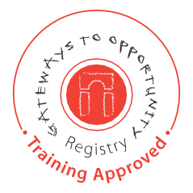

Illinois AfterSchool Network is a Gateways to Opportunity® Registry Authorized Entity
As always, if you have any questions, please email us at ianetwrk@att.net. Many thanks for your continued support of our work in the field of after school and youth development.

