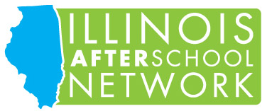

Illinois AfterSchool Network 33rd Annual Spring Conference
Saturday, April 27, 2019
General Schedule

7:30am: Registration Opens, Market Place Opens
Continental Breakfast
8:15 – 9:15am: Session One
Welcome and ACT Now Coalition Call to Action Meeting

9:30 – 11:00am: Session Two

11:15am – 12:45pm: Session Three
1:00 – 2:30pm: Session Four
Luncheon, Keynote address and Awards Presentation

2:45 – 4:15pm: Session Five

4:15pm: Conference Adjourned and Giveaways
Market Place Area

2019 Spring Conference highlights
- Luncheon keynote speaker: Nicole Lovecchio, Chief Program Officer, Wings for Kids in Charleston South Carolina
- This year you can earn up to six hours of training for the day-long event
- Presentation of the Rich Scofield, IAN Best Practice and Deb Nelson Board Leadership Awards
- Youth Presenter and Entertainment
- Active Market Place with a plethora of resources
- Specialize time in between sessions to network with professionals from across the state

